TASK 1:

Write a C++ program to print the following pattern on the screen. Ask user to enter a integer value from 1 to 10. Use while loop.

**#Sample Program Run#1**

**Enter a integer value: 7**

**X X X X X X X**

**X X X X X X**

**X X X X X**

**X X X X**

**X X X**

**X X**

**X**

**Source Code:**

#include <iostream>

using namespace std;

int main()

{

//declaring variables:

int a,b=1;

//enter value from 1-10:

cout <<"Enter a integer value from 1 to 10: ";

cin>> a;

cout<<"\n";

//Apply nested while loop:

while(a>=1)

{

int b=1;

while(b<=a)

{

cout<<"X";

b++;

}

a--;

cout<<endl;

}

return 0;

}

**Screenshot:**

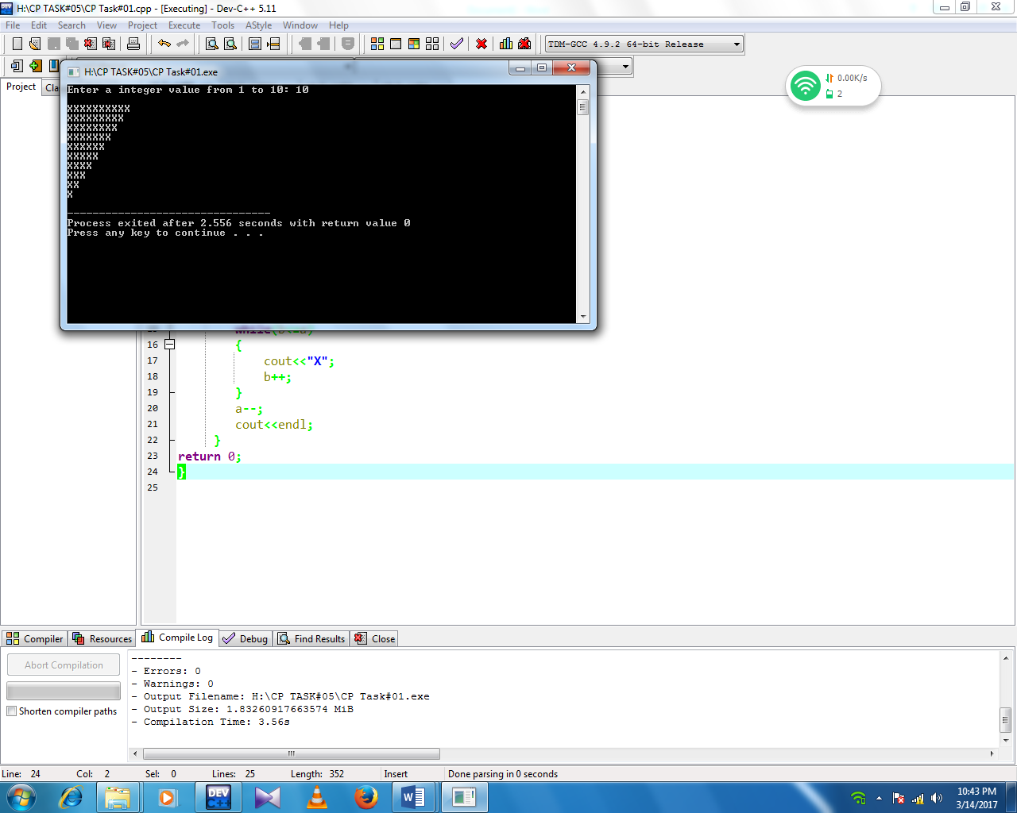

TASK 2:

By applying for loop, write a C++ program that prints

1. A sequence of numbers in ascending order from 1 to 100 (inclusive).
2. Modify your program in part (a) to make it prints odd numbers within 1 to 100.
3. Write a C++ Program that receives a positive integer (N) and prints a series of numbers from 1 to N (inclusive) in ascending order.
4. Write a C++ Program that displays a series of alphabets in descending order from ‘Z’ to ‘A’.
5. Modify your program in part (d) so that the program will display consonants only, no vowels.
6. Write a C++ program that receives start value and end value. Then, your program will display a series of numbers from the start value to the end value inclusive.

**Source Code:**

#include<iostream>

using namespace std;

int main()

{

int a,b,c,num4,num5;

//(a):

//enter integer from 1-100:

cout<<"Enter any integer number from 1 to 100: ";

cin>>a;

//apply for loop:

for(int num1=100;a<=num1;a++)

{

cout<<a<<endl;

}

//(b):

//enter num from 1-100 and make it print in odd series:

cout<<"\n"<<"Enter any integer number from 1 to 100: ";

cin>>b;

//apply for loop:

for(int num2=100;b<=num2;b++)

{

if(b%2==1)

cout<<b<<endl;

}

//(c):

//enter integer num and make it print from 1-N:

cout<<"\n"<<"Enter any integer number: ";

cin>>c;

//apply for loop:

for(int num3=1;c>=num3;c--)

{

cout<<c<<endl;

}

//(d)(e):

//enter any alphabet and prints it in decending order:

char alph,x;

cout<<"\n"<<"Enter any Alphabets: ";

cin>>alph;

if(alph<='z')

{

for(x='z';x>=alph;x--)

{

if(x!='a' && x!='e' && x!='i' && x!='o' && x!='u')

{

cout<<x<<endl;

}

}

}

//(f):

//enter starting & ending value:

cout<<"\n"<<"Enter starting value: ";

cin>>num4;

cout<<"\n"<<"Enter ending value: ";

cin>>num5;

for(;num4<=num5;num4++)

{

if(num4>num5)

{

cout<<"wrong input.try again "<<endl;

}

cout<<num4<<endl;

}

cout<<"\n"<<"Thank You Very Much."<<endl;

return 0;

}

**Screenshot:**

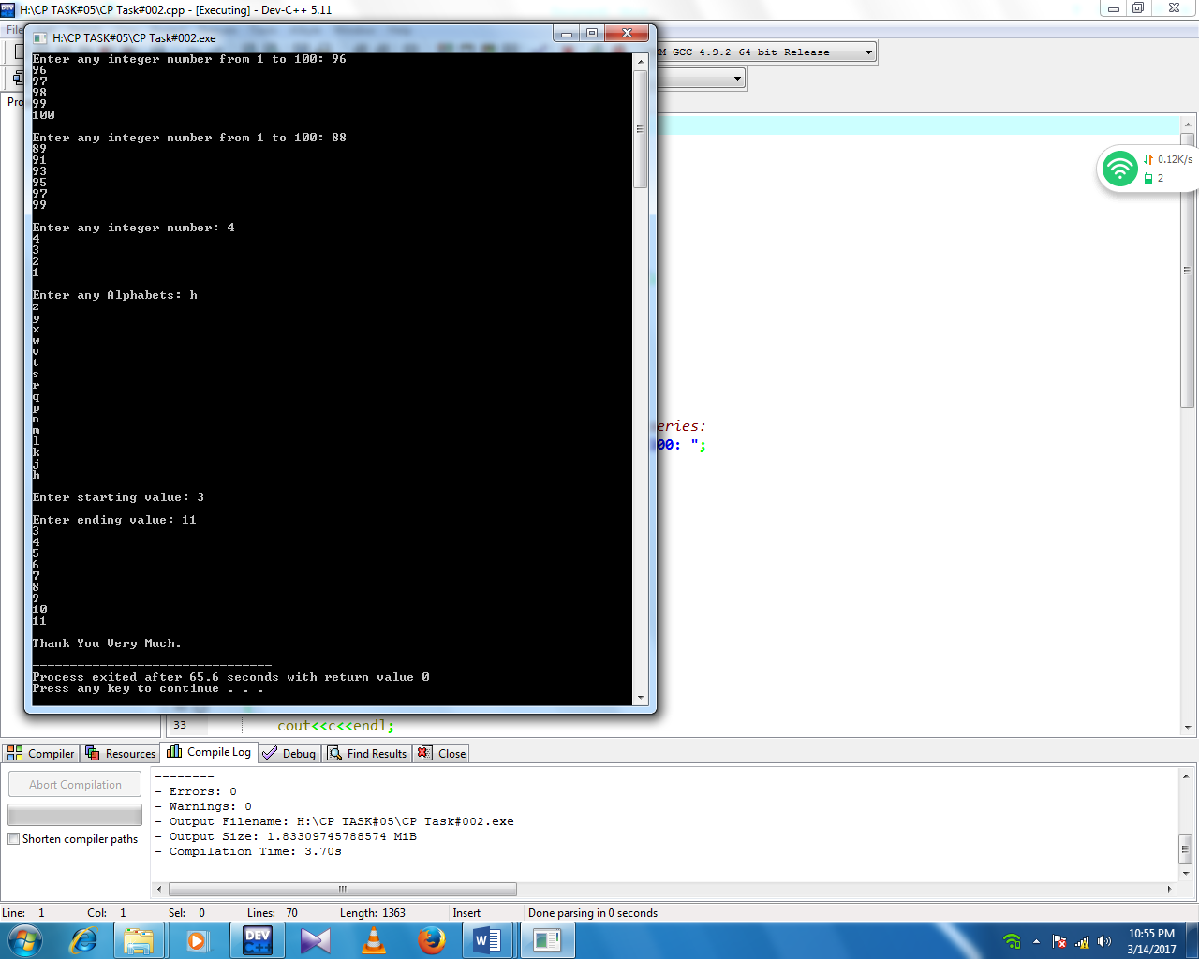

TASK 3:

Write a C++ program that take two numbers from user, min and max. Use do-while to

make sure that the user enters the smaller value first. Then your program will compute the sum of all integer numbers from min to max. Use do While loop.

Your Program should display output as follows:

**#Sample Program Run#1**

**Enter min and max value: 21 18**

**Wrong input please try again.**

**Enter min and max value: 11 15**

**Sum of values from 11 to 15 is : 65**

**Thank You!!**

**Source Code:**

#include <iostream>

using namespace std;

int main()

{

int min,max,sum,d;

do

{

cout<<"\n"<<"Enter min & max value: "<<endl;

cin>>min>>max;

if(min>max)

{

cout<<"\n"<<"wrong input.Please try again: "<<endl;

cout<<"\n"<<"Enter min & max value: "<<endl;

cin>>min>>max;

}

for(;min<=max;min++)

{

sum+=min;

}

}while(min<max);

cout<<"\n"<<"sum of values from a to b is:"<<sum<<endl;

return 0;

}

**Screenshot:**

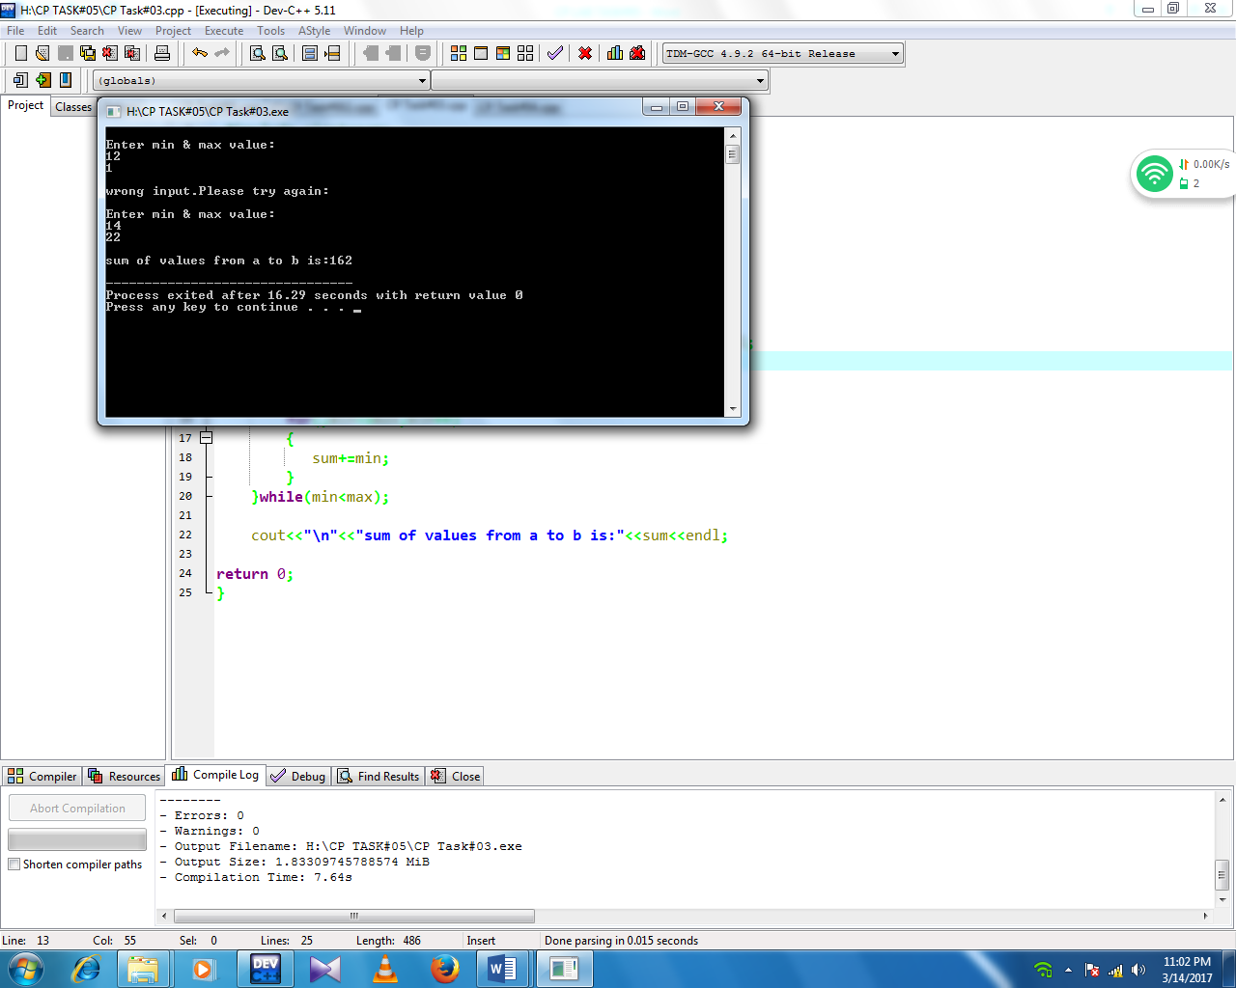

TASK 4:

Write a C++ program that takes a positive integer from user and store it in variable *posNumber*. Follow these conditions;

If the number is less than 1, print wrong input.

If it is 1, Print its value.

If value is greate than 1, check the value is it Even or Odd.

If it is Even, half it and print.

If it is Odd, multiply it by 3 and print result.

Repeat the whole process until user enter 1.

**#Sample Program Run#1**

**Enter a integer value > = to 1: 0**

**Wrong Input, please try again.**

**Enter a integer value > = to 1: 1**

**Value is : 1. Thank You**

**#Sample Program Run#2**

**Enter a integer value > = to 1: 6**

**Value is 3**

**Enter a integer value > = to 1: 11**

**Value is 33**

**Enter a integer value > = to 1: 56**

**Value is 23**

**Enter a integer value > = to 1: 1**

**Value is 1. Thank You.**

**Source Code:**

#include <iostream>

using namespace std;

int main()

{

int a,b,num,posNumber;

do

{

cout<<"\n"<<"Enter any integer Positive number >=1: ";

cin>>num;

posNumber=num;

if(posNumber<1)

{

cout<<"\n"<<"Wrong Input Please try again."<<endl;

}

else if(posNumber==1)

{

cout<<"\n"<<"Value is "<<posNumber<<" Thank you:"<<endl;

}

else if(posNumber==1)

{

cout<<"\n"<<"Value is "<<posNumber<<" Thank you:"<<endl;

}

else if(posNumber>1)

{

if(posNumber%2==0)

{

cout<<"\n"<<"The number is Even: ";

posNumber=posNumber/2;

cout<<posNumber<<endl;

}

else if(posNumber%2==1)

{

cout<<"\n"<<"The number is Odd: ";

posNumber=posNumber*2;

cout<<posNumber<<endl;

}

}

}while(posNumber>1);

return 0;

}

**Screenshot:**

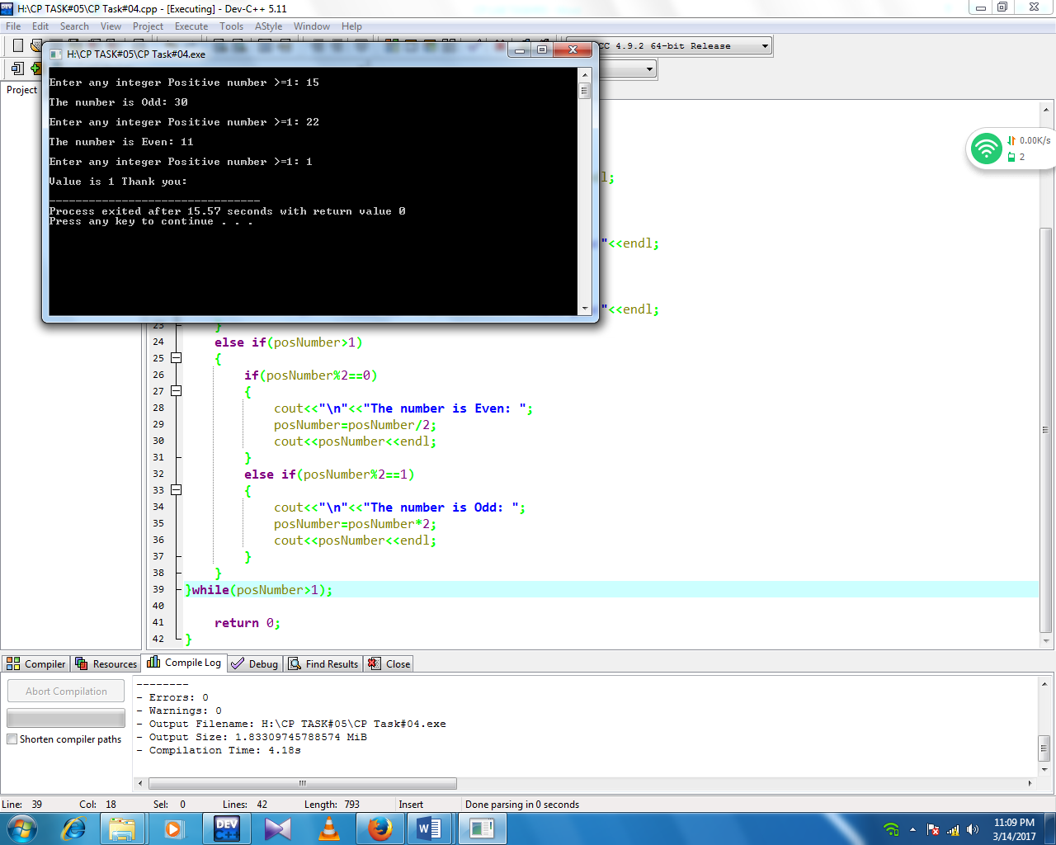

TASK 5:

Write a C++ program that receives the total number of integers (N). Then, the program will ask for N real numbers. By applying for loop, your program should find and display the largest and the lowest of the numbers. Give a proper message for invalid user input.

**#Sample Program Run#1**

**How many numbers do you have? > -3**

**Sorry, you have entered an invalid input.**

**Thank you.**

**#Sample Program Run#2**

**How many numbers do you have? > 0**

**Opps, you don't have any number for me to process.**

**Thank you.**

**#Sample Program Run#3**

**How many numbers do you have? > 5**

**Please enter a number_1 --> 12.5**

**Please enter a number_2 --> -3.2**

**Please enter a number_3 --> 0**

**Please enter a number_4 --> 5**

**Please enter a number_5 --> 8.5**

**The lowest number is -3.20**

**The highest number is 12.50**

**Thank you.**

**Source Code:**

#include<iostream>

using namespace std;

int main()

{

int n,i,a;

cout<<"Enter any integer real number:";

cin>>n;

cout<<"\n"<<"Enter number:";

cin>>i;

int min=a,max=a;

if(n<0)

cout<<"\n"<<"Please enter a valid input";

if(n==0)

cout<<"\n"<<"Oops you enter a invalid input";

if(n>=1)

{

for(int x=1;x<=n;x++)

{

cout<<"\n"<<"enter number "<<x<<":";

cin>>a;

if(n>max)

{

max=a;

}

if(n<min)

{

min=a;

}

}

cout<<"largest="<<max<<" "<<"lowest="<<min;

}

return 0;

}

**Screenshot:**

